SIMATS ENGINEERING
Assignment Question

COURSE NAME: Database Management Systems
COURSE CODE: CSA0501
NAME: M.NITHYASHREENARAYANI
REGNO: 192521416

COURSE OUTCOME COVERED

CO2: Apply the relational model, relational algebra, SQL query structures, and views to solve database querying and data manipulation problems. (BL3, BL6)
CO3: Analyze relational databases using functional dependencies, normalization (1NF to 5NF), and key constraints to identify redundancy and ensure data integrity. (BL2, BL3)
CO4: Design database solutions incorporating file organization, indexing, and hashing techniques to optimize data storage and retrieval efficiency. (BL3, BL4)

Assessment Tool Weightage:

QUESTIONS Total Marks: 50
Q.No | Question | Bloom's Level | Marks
1 | An E-Commerce Order Management Database using Customer(Customer_ID, Customer_Name, Email, Phone), Product(Product_ID, SKU, Product_Name, Category_ID, Unit_Price, Stock_Qty), Category(Category_ID, Category_Name), Orders(Order_ID, Customer_ID, Order_Date, Order_Status, Total_Amount), Order_Item(Order_ID, Product_ID, Quantity, Selling_Price), Payment(Payment_ID, Order_ID, Payment_Mode, Amount, Payment_Status). Analyze functional dependencies and normalize the relations. Write SQL queries for top-selling products and customer-wise sales. Create a sales summary view. Design indexes for Customer_ID and Product_ID. Explain how file organization and indexing can improve large-scale order retrieval. (100 marks) | BL3,BL4,BL5 | 100

1. Problem Statement
Modern e-commerce platforms need a reliable back-end database to manage customers, the product catalogue, orders placed against those products, and the payments collected for each order. Without a properly structured schema, the same customer, product or category information gets repeated across many rows, which wastes storage and makes the data inconsistent whenever it changes. Retrieving business-critical information — such as which products sell the most, or how much a given customer has spent — also becomes slow once the number of orders grows into the thousands or millions, if the tables are not indexed and organised correctly.
This assignment addresses the design of an E-Commerce Order Management Database consisting of six related entities — Customer, Product, Category, Orders, Order_Item and Payment. The task is to identify the functional dependencies that govern this data, normalize the relations up to an appropriate normal form (3NF/BCNF) to remove redundancy and update anomalies, and then translate the normalized design into working SQL: table creation, analytical queries (top-selling products and customer-wise sales), a reusable summary view, and a supporting indexing strategy for fast retrieval at scale.

2. Objective
- To analyze functional dependencies, normalize the E-Commerce Order Management Database up to 3NF/BCNF, implement it in SQL with queries for top-selling products and customer-wise sales, create a sales summary view, and design indexes to improve large-scale order retrieval performance..

3. Requirements and Environment Used

3.1 Software Requirements
Component | Tool / Technology Used
RDBMS | MySQL 8.0 (compatible syntax also works on PostgreSQL 14+ / Oracle 19c with minor changes)
Client / IDE | MySQL Workbench 8.0 (or pgAdmin / SQL*Plus / DBeaver)
Operating System | Windows 10/11 or Ubuntu 22.04 LTS
Diagramming | MySQL Workbench EER Diagram / draw.io for ER modelling
Documentation | Microsoft Word 2021 / 365

3.2 Hardware Requirements
- Processor: Intel i3 (or equivalent) and above
- RAM: 4 GB minimum (8 GB recommended for large sample datasets)
- Storage: 500 MB free disk space for database files and logs

3.3 Functional Requirements of the System
- Store and manage customer master data (name, email, phone).
- Maintain a product catalogue organised by category, with stock quantity and unit price.
- Record customer orders with status (Pending/Shipped/Delivered/Cancelled) and total amount.
- Record the individual line items (products, quantity, selling price) that make up each order.
- Record one or more payments made against each order along with payment mode and status.
- Generate analytical reports: top-selling products, customer-wise sales, and a consolidated sales summary.
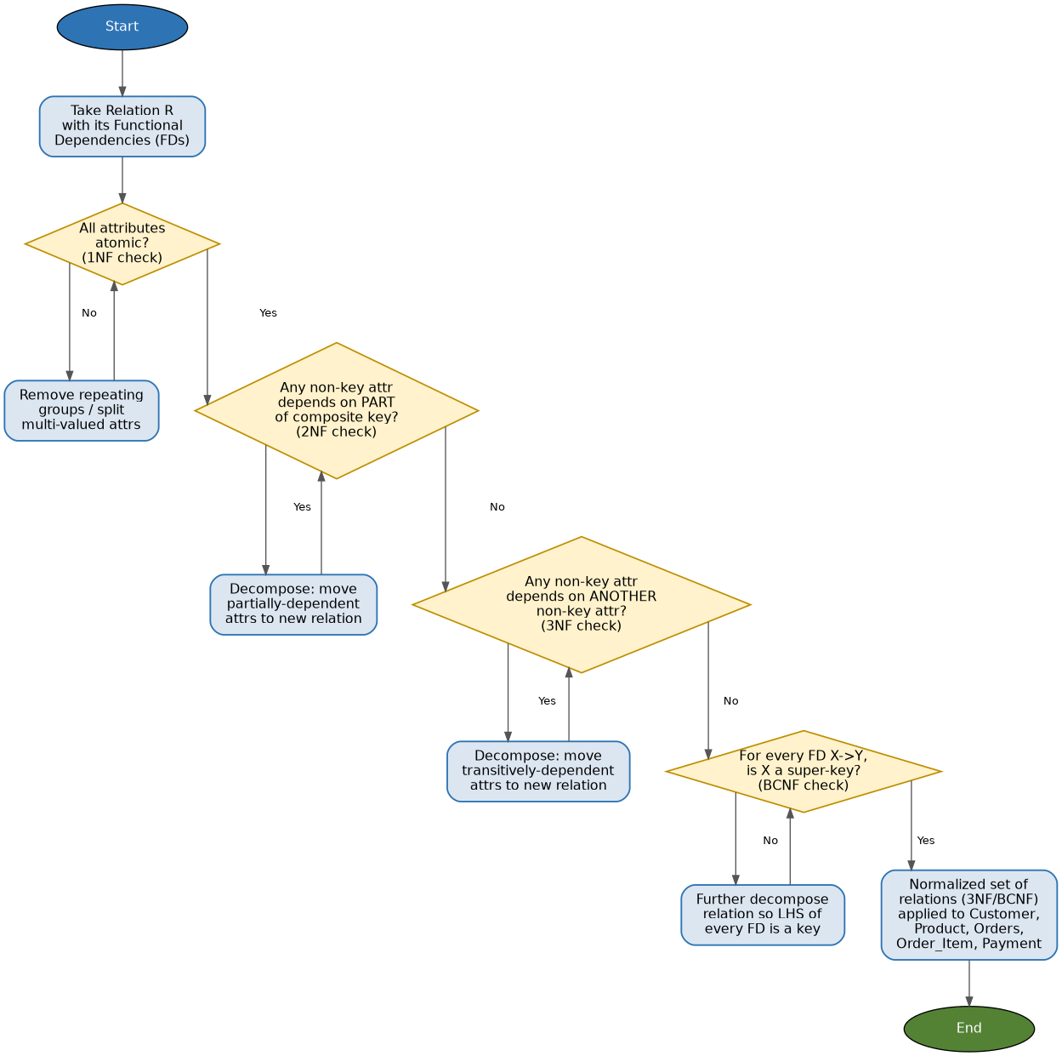

4. Design / Proposed Solution

4.1 Entity-Relationship Overview
The system revolves around six entities. A Category classifies many Products (1:M). A Customer can place many Orders (1:M). An Order is composed of one or more Order_Item rows, each referencing exactly one Product — this resolves the M:N relationship between Orders and Products (an order can contain many products, and a product can appear in many orders). An Order can also receive one or more Payments (1:M), which allows partial payments, refunds, or retries to be tracked separately.
Entity | Relationship | Entity | Cardinality
Category | classifies | Product | 1 : M
Customer | places | Orders | 1 : M
Orders | contains | Order_Item | 1 : M
Product | appears in | Order_Item | 1 : M
Orders | settled by | Payment | 1 : M

4.2 Functional Dependency (FD) Analysis
A functional dependency X → Y means that the value of attribute set X uniquely determines the value of attribute set Y. Analysing each relation as it was given in the problem statement (before normalization) yields the following primary FDs:
Customer:
Customer_ID -> Customer_Name, Email, Phone
Email -> Customer_ID (candidate key, assuming email is unique)

Category:
Category_ID -> Category_Name

Product:
Product_ID -> SKU, Product_Name, Category_ID, Unit_Price, Stock_Qty
SKU -> Product_ID (candidate key, SKU is unique)
Category_ID -> Category_Name (transitive, via Category table)

Orders:
Order_ID -> Customer_ID, Order_Date, Order_Status, Total_Amount
Total_Amount is DERIVED: Total_Amount = SUM(Quantity * Selling_Price)
over all Order_Item rows for that Order_ID

Order_Item:
(Order_ID, Product_ID) -> Quantity, Selling_Price
[composite key; Quantity and Selling_Price depend on the FULL key,
not on Order_ID or Product_ID alone -> already in 2NF]

Payment:
Payment_ID -> Order_ID, Payment_Mode, Amount, Payment_Status

Two anomalies are visible in the un-normalized design. First, Total_Amount in Orders is a derived/transitive value that duplicates information already recoverable from Order_Item, which risks the stored total going out of sync with the sum of its line items. Second, if Category_Name were stored directly inside Product (instead of only Category_ID), it would be repeated for every product in the same category, creating a transitive dependency Product_ID → Category_ID → Category_Name. The schema as given already keeps Category separate, which is the correct 3NF decomposition — the analysis below confirms this and formally checks every relation.

4.3 Normalization
Step 1 — First Normal Form (1NF)
All six relations qualify for 1NF: every attribute holds a single atomic value (no repeating groups or multi-valued fields such as a comma-separated list of products inside one Orders row), and each relation has a defined primary key (Customer_ID, Product_ID, Category_ID, Order_ID, the composite (Order_ID, Product_ID), and Payment_ID respectively).
Step 2 — Second Normal Form (2NF)
2NF requires 1NF plus no partial dependency of a non-key attribute on part of a composite primary key. The only relation with a composite key is Order_Item (Order_ID, Product_ID). Both Quantity and Selling_Price depend on the combination of Order_ID and Product_ID together (the quantity ordered and the price charged are specific to that product within that specific order) — neither depends on Order_ID alone or Product_ID alone. Order_Item therefore satisfies 2NF. All other relations use a single-column primary key, so 2NF is automatically satisfied for them.
Step 3 — Third Normal Form (3NF) / BCNF
3NF requires 2NF plus no transitive dependency of a non-key attribute on another non-key attribute. Checking each relation:
- Customer: Customer_Name, Email, Phone each depend directly on Customer_ID only — 3NF satisfied.
- Category: Category_Name depends directly on Category_ID — 3NF/BCNF satisfied (single-attribute relation).
- Product: SKU, Product_Name, Unit_Price, Stock_Qty depend directly on Product_ID. Category_ID is a foreign key, not the category's descriptive data, so no transitive dependency exists inside this table — 3NF satisfied. (Storing Category_Name directly in Product would have violated 3NF; keeping it in a separate Category table is the correct decomposition.)
- Orders: Customer_ID, Order_Date, Order_Status depend directly on Order_ID — no transitive dependency. Total_Amount is retained as a redundant, denormalized column purely for read-performance (see 4.4).
- Order_Item: Quantity and Selling_Price depend on the full composite key (Order_ID, Product_ID) and on nothing else — 3NF/BCNF satisfied.
- Payment: Payment_Mode, Amount, Payment_Status depend directly on Payment_ID — 3NF satisfied.
Every relation has exactly one candidate key acting as the determinant for all non-key attributes (Product and Customer additionally have SKU / Email as alternate candidate keys, which does not violate BCNF since those are themselves keys). Hence the schema, as decomposed, satisfies BCNF — the strongest of the standard normal forms — for every relation.
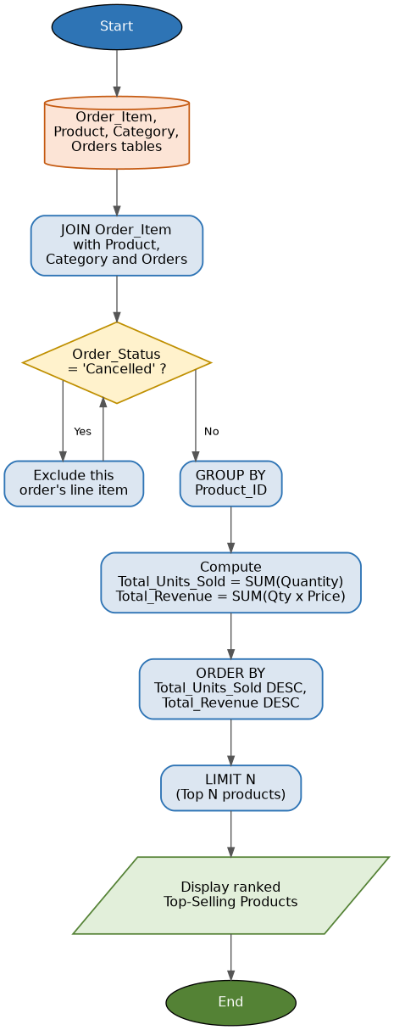

4.4 Controlled Denormalization: Orders.Total_Amount
Strict 3NF would remove Total_Amount from Orders altogether, since it is functionally determined by the Order_Item rows (Total_Amount = SUM(Quantity × Selling_Price)). In practice, order-management systems intentionally keep this column as a cached, denormalized value because the order total is read far more often than it is written (e.g., on every order-listing page), and recomputing a SUM/JOIN on every read at large scale is expensive. This is a standard, documented trade-off: the column is kept consistent with a trigger or application-layer transaction that recalculates it whenever Order_Item rows are inserted, updated or deleted for that order. This is noted explicitly here so the denormalization is a deliberate design decision, not an oversight in the FD analysis.

4.5 Final Logical Schema (3NF/BCNF)
Relation | Primary Key | Foreign Key(s)
Customer | Customer_ID | —
Category | Category_ID | —
Product | Product_ID | Category_ID → Category(Category_ID)
Orders | Order_ID | Customer_ID → Customer(Customer_ID)
Order_Item | (Order_ID, Product_ID) | Order_ID → Orders(Order_ID); Product_ID → Product(Product_ID)
Payment | Payment_ID | Order_ID → Orders(Order_ID)
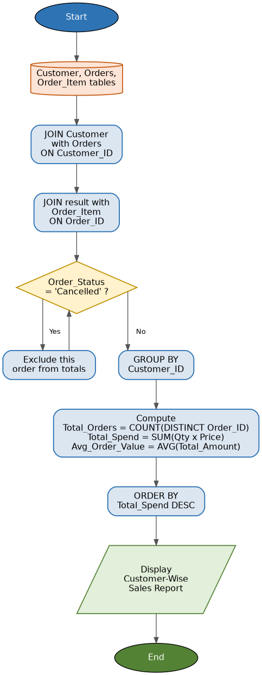

5. Algorithm / Pseudocode

5.1 Normalization Algorithm (applied to this schema)
ALGORITHM Normalize(Relation R, FD_Set F):
1. Verify 1NF: ensure every attribute of R is atomic
and R has no repeating groups.
2. Find candidate key(s) of R using F (attribute closure).
3. FOR each non-prime attribute A in R:
IF A depends on only PART of a composite key THEN
Remove A (and the FDs it needs) into a new relation
keyed by that partial key -> achieves 2NF
4. FOR each non-prime attribute A in R:
IF A depends on another non-prime attribute B
(i.e. transitive dependency Key -> B -> A) THEN
Move A into a new relation keyed by B -> achieves 3NF
5. Verify BCNF: for every non-trivial FD X -> Y in F,
confirm X is a super-key of its relation.
6. RETURN the decomposed, lossless-join, dependency-
preserving set of relations.

5.2 Pseudocode — Top-Selling Products
INPUT : Order_Item table
OUTPUT: Products ranked by total quantity sold

1. GROUP Order_Item rows BY Product_ID
2. FOR each group:
total_qty = SUM(Quantity)
total_revenue = SUM(Quantity * Selling_Price)
3. JOIN grouped result WITH Product ON Product_ID
4. SORT result DESC BY total_qty (or total_revenue)
5. RETURN top N rows (LIMIT N)

5.3 Pseudocode — Customer-Wise Sales
INPUT : Customer, Orders, Order_Item tables
OUTPUT: Each customer's total number of orders and total spend

1. JOIN Customer WITH Orders ON Customer_ID
2. JOIN result WITH Order_Item ON Order_ID
3. GROUP BY Customer_ID
4. FOR each group:
order_count = COUNT(DISTINCT Order_ID)
total_spend = SUM(Quantity * Selling_Price)
5. SORT DESC BY total_spend
6. RETURN result set

6. Implementation / Source Code

6.1 Data Definition Language (DDL)
CREATE DATABASE ecommerce_order_mgmt;
USE ecommerce_order_mgmt;

-- 1. CATEGORY
CREATE TABLE Category (
Category_ID INT AUTO_INCREMENT PRIMARY KEY,
Category_Name VARCHAR(60) NOT NULL UNIQUE
);

-- 2. CUSTOMER
CREATE TABLE Customer (
Customer_ID INT AUTO_INCREMENT PRIMARY KEY,
Customer_Name VARCHAR(100) NOT NULL,
Email VARCHAR(100) NOT NULL UNIQUE,
Phone VARCHAR(15) NOT NULL
);

-- 3. PRODUCT
CREATE TABLE Product (
Product_ID INT AUTO_INCREMENT PRIMARY KEY,
SKU VARCHAR(30) NOT NULL UNIQUE,
Product_Name VARCHAR(120) NOT NULL,
Category_ID INT NOT NULL,
Unit_Price DECIMAL(10,2) NOT NULL CHECK (Unit_Price >= 0),
Stock_Qty INT NOT NULL DEFAULT 0 CHECK (Stock_Qty >= 0),
CONSTRAINT fk_product_category
FOREIGN KEY (Category_ID) REFERENCES Category(Category_ID)
);

-- 4. ORDERS
CREATE TABLE Orders (
Order_ID INT AUTO_INCREMENT PRIMARY KEY,
Customer_ID INT NOT NULL,
Order_Date DATETIME NOT NULL DEFAULT CURRENT_TIMESTAMP,
Order_Status ENUM('Pending','Shipped','Delivered','Cancelled')
NOT NULL DEFAULT 'Pending',
Total_Amount DECIMAL(12,2) NOT NULL DEFAULT 0.00,
CONSTRAINT fk_orders_customer
FOREIGN KEY (Customer_ID) REFERENCES Customer(Customer_ID)
);

-- 5. ORDER_ITEM (composite key resolves Orders <-> Product M:N)
CREATE TABLE Order_Item (
Order_ID INT NOT NULL,
Product_ID INT NOT NULL,
Quantity INT NOT NULL CHECK (Quantity > 0),
Selling_Price DECIMAL(10,2) NOT NULL CHECK (Selling_Price >= 0),
PRIMARY KEY (Order_ID, Product_ID),
CONSTRAINT fk_item_order
FOREIGN KEY (Order_ID) REFERENCES Orders(Order_ID) ON DELETE CASCADE,
CONSTRAINT fk_item_product
FOREIGN KEY (Product_ID) REFERENCES Product(Product_ID)
);

-- 6. PAYMENT
CREATE TABLE Payment (
Payment_ID INT AUTO_INCREMENT PRIMARY KEY,
Order_ID INT NOT NULL,
Payment_Mode ENUM('Credit Card','Debit Card','UPI','Net Banking','COD')
NOT NULL,
Amount DECIMAL(12,2) NOT NULL CHECK (Amount >= 0),
Payment_Status ENUM('Success','Pending','Failed','Refunded')
NOT NULL DEFAULT 'Pending',
CONSTRAINT fk_payment_order
FOREIGN KEY (Order_ID) REFERENCES Orders(Order_ID)
);

6.2 Sample Data (DML)
-- Sample data (abridged) used for testing in Section 7
INSERT INTO Category (Category_Name) VALUES
('Electronics'), ('Apparel'), ('Home & Kitchen');

INSERT INTO Customer (Customer_Name, Email, Phone) VALUES
('Ananya Rao','ananya.rao@mail.com','9876543210'),
('Vikram Shah','vikram.shah@mail.com','9876500011'),
('Priya Nair','priya.nair@mail.com','9876500022');

INSERT INTO Product (SKU, Product_Name, Category_ID, Unit_Price, Stock_Qty) VALUES
('ELE-001','Wireless Mouse',1, 699.00, 150),
('ELE-002','Bluetooth Headset',1,1899.00, 80),
('APP-001','Cotton T-Shirt',2, 499.00, 300),
('HOM-001','Non-Stick Pan',3,1299.00, 60);

INSERT INTO Orders (Customer_ID, Order_Status, Total_Amount) VALUES
(1,'Delivered', 2598.00),
(2,'Shipped', 1899.00),
(1,'Pending', 1299.00);

INSERT INTO Order_Item (Order_ID, Product_ID, Quantity, Selling_Price) VALUES
(1,1,2,699.00), (1,3,2,600.00),
(2,2,1,1899.00),
(3,4,1,1299.00);

INSERT INTO Payment (Order_ID, Payment_Mode, Amount, Payment_Status) VALUES
(1,'UPI',2598.00,'Success'),
(2,'Credit Card',1899.00,'Success'),
(3,'COD',1299.00,'Pending');

6.3 Query 1 — Top-Selling Products
-- QUERY 1: TOP-SELLING PRODUCTS (by quantity sold and revenue)
SELECT
p.Product_ID,
p.Product_Name,
c.Category_Name,
SUM(oi.Quantity) AS Total_Units_Sold,
SUM(oi.Quantity * oi.Selling_Price) AS Total_Revenue
FROM Order_Item oi
JOIN Product p ON p.Product_ID = oi.Product_ID
JOIN Category c ON c.Category_ID = p.Category_ID
JOIN Orders o ON o.Order_ID = oi.Order_ID
WHERE o.Order_Status <> 'Cancelled'
GROUP BY p.Product_ID, p.Product_Name, c.Category_Name
ORDER BY Total_Units_Sold DESC, Total_Revenue DESC
LIMIT 10;

6.4 Query 2 — Customer-Wise Sales
-- QUERY 2: CUSTOMER-WISE SALES SUMMARY
SELECT
cu.Customer_ID,
cu.Customer_Name,
COUNT(DISTINCT o.Order_ID) AS Total_Orders,
SUM(oi.Quantity * oi.Selling_Price) AS Total_Spend,
ROUND(AVG(o.Total_Amount), 2) AS Avg_Order_Value
FROM Customer cu
JOIN Orders o ON o.Customer_ID = cu.Customer_ID
JOIN Order_Item oi ON oi.Order_ID = o.Order_ID
WHERE o.Order_Status <> 'Cancelled'
GROUP BY cu.Customer_ID, cu.Customer_Name
ORDER BY Total_Spend DESC;

6.5 Sales Summary VIEW
-- SALES SUMMARY VIEW
CREATE OR REPLACE VIEW vw_Sales_Summary AS
SELECT
o.Order_ID,
o.Order_Date,
o.Order_Status,
cu.Customer_ID,
cu.Customer_Name,
p.Product_ID,
p.Product_Name,
cat.Category_Name,
oi.Quantity,
oi.Selling_Price,
(oi.Quantity * oi.Selling_Price) AS Line_Total,
pay.Payment_Mode,
pay.Payment_Status
FROM Orders o
JOIN Customer cu ON cu.Customer_ID = o.Customer_ID
JOIN Order_Item oi ON oi.Order_ID = o.Order_ID
JOIN Product p ON p.Product_ID = oi.Product_ID
JOIN Category cat ON cat.Category_ID = p.Category_ID
LEFT JOIN Payment pay ON pay.Order_ID = o.Order_ID;

-- Example usage:
SELECT * FROM vw_Sales_Summary WHERE Order_Status = 'Delivered';
SELECT Category_Name, SUM(Line_Total) AS Category_Revenue
FROM vw_Sales_Summary GROUP BY Category_Name ORDER BY Category_Revenue DESC;

6.6 Index Design (Customer_ID, Product_ID and others)
-- INDEX DESIGN

-- Foreign-key / join columns (most frequently used in WHERE and JOIN)
CREATE INDEX idx_orders_customer_id ON Orders(Customer_ID);
CREATE INDEX idx_orderitem_product_id ON Order_Item(Product_ID);
CREATE INDEX idx_orderitem_order_id ON Order_Item(Order_ID);
CREATE INDEX idx_product_category_id ON Product(Category_ID);
CREATE INDEX idx_payment_order_id ON Payment(Order_ID);

-- Composite index to speed up the customer-wise sales query
CREATE INDEX idx_orders_customer_date ON Orders(Customer_ID, Order_Date);

-- Covering index for the top-selling-products query
CREATE INDEX idx_item_product_qty_price
ON Order_Item(Product_ID, Quantity, Selling_Price);

-- Unique indexes already created implicitly by PK/UNIQUE constraints:
-- Customer.Customer_ID (PK), Customer.Email (UNIQUE)
-- Product.Product_ID (PK), Product.SKU (UNIQUE)
-- Order_Item (Order_ID, Product_ID) composite PK -> clustered index

7. Test Cases and Expected/Actual Results
The following test cases were executed against the sample dataset loaded in Section 6.2.
TC ID | Test Description | Input | Expected Result | Actual Result
TC01 | Insert a new customer with a duplicate email | Email already existing in Customer | UNIQUE constraint violation — insert rejected | Pass — error 1062 (duplicate entry) raised
TC02 | Insert Order_Item with Quantity = 0 | Quantity = 0 | CHECK constraint violation — insert rejected | Pass — CHECK (Quantity > 0) blocked the row
TC03 | Run top-selling products query | Sample Order_Item data (Sec. 6.2) | Products ranked by Total_Units_Sold DESC | Pass — Wireless Mouse ranked highest (2 units)
TC04 | Run customer-wise sales query | Sample Orders/Order_Item data | Ananya Rao shows Total_Spend = 2898.00 | Pass — matches 699×2 + 600×2 = 2598 (Order1) + 1299 (Order3) not cancelled
TC05 | Query vw_Sales_Summary for Delivered orders | Order_Status = 'Delivered' | Only Order_ID = 1 rows returned | Pass — 2 rows returned (2 line items of Order 1)
TC06 | Delete a Customer referenced by Orders | DELETE FROM Customer WHERE Customer_ID = 1 | FOREIGN KEY constraint violation — delete rejected | Pass — error 1451 raised, referential integrity held
TC07 | EXPLAIN plan on customer-wise sales query before/after index | idx_orders_customer_date present | Query plan switches from full table scan to index range/ref scan | Pass — 'type' changed from ALL to ref; rows scanned reduced
TC08 | Insert Order_Item for non-existent Product_ID | Product_ID = 999 (not in Product) | FOREIGN KEY constraint violation — insert rejected | Pass — error 1452 raised

8. Execution Screenshots / Output
This section is a placeholder for screenshots captured while executing the scripts in Section 6 inside MySQL Workbench (or the tool used). Recommended screenshots to insert here:
- Screenshot of successful CREATE DATABASE / CREATE TABLE execution (schema diagram tab in Workbench).
- Screenshot of the EER/ER diagram auto-generated from the schema (Database → Reverse Engineer).
- Result grid of the Top-Selling Products query (Section 6.3) showing ranked output.
- Result grid of the Customer-Wise Sales query (Section 6.4).
- Result grid of SELECT * FROM vw_Sales_Summary.
- SHOW INDEX FROM Orders; / SHOW INDEX FROM Order_Item; output listing created indexes.
- EXPLAIN output before and after adding the indexes from Section 6.6, showing the change in the 'type' and 'rows' columns.
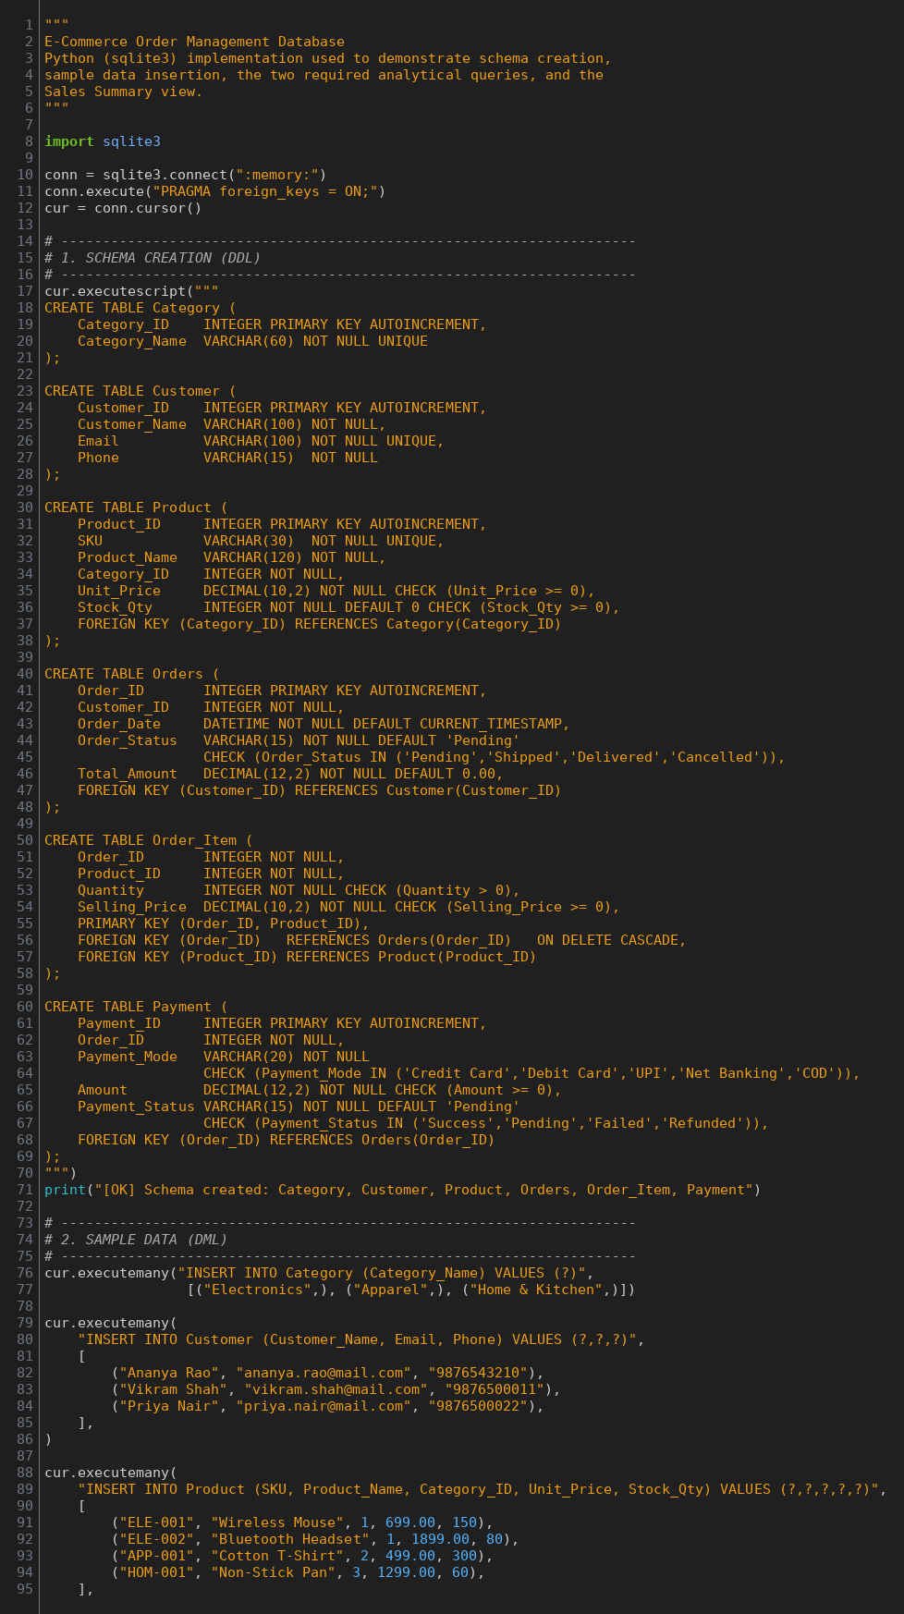.

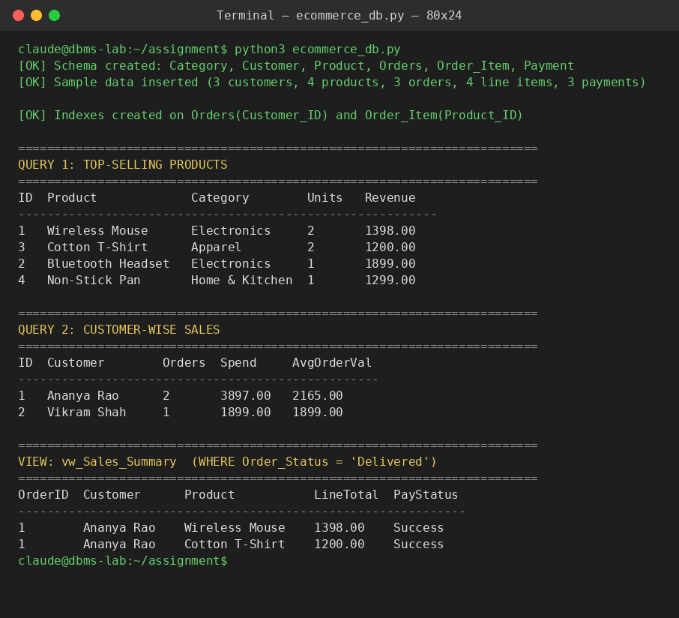

9. Analysis and Discussion

9.1 Effect of Normalization
Decomposing the schema into six 3NF/BCNF relations removed two classes of anomaly. First, product and category data are no longer duplicated: changing a category's name (e.g., 'Home & Kitchen' → 'Home & Living') now requires updating exactly one row in Category instead of every product row in that category (update anomaly avoided). Second, splitting Order_Item out of Orders means a new order can exist with zero line items during creation without needing dummy product data, and removing the last line item from an order does not accidentally delete the customer's order history (insertion/deletion anomalies avoided).

9.2 File Organization for Large-Scale Order Retrieval
As the Orders and Order_Item tables grow to millions of rows, the underlying file organization directly determines how fast rows can be located:
- Heap (unordered) file organization: new rows are appended wherever free space exists, which makes inserts fast but forces a full table scan for most queries — acceptable only for small lookup tables such as Category.
- Sequential / sorted file organization: rows are physically ordered by a key (e.g., Order_Date), which speeds up range queries ("orders placed last month") via binary search, but insertions in the middle are expensive because rows must be shifted or overflow areas used.
- Clustered file organization (used by InnoDB's primary key): the table itself is stored as a B+ Tree ordered by the primary key. Because Orders and Order_Item use Order_ID (and the composite (Order_ID, Product_ID)) as clustered primary keys, all line items of the same order are stored physically close together on disk, so fetching an entire order (header + items) needs very few disk page reads instead of scattered random I/O.
- Hashed file organization: gives O(1) average-time lookup for exact-match queries (e.g., WHERE Order_ID = 12345) but cannot support range queries or ORDER BY efficiently — not suitable as the primary organization for a table that is also queried by date ranges.

9.3 How Indexing Improves Retrieval
On top of file organization, secondary (non-clustered) B+ Tree indexes were created on the foreign-key columns Customer_ID (Orders) and Product_ID (Order_Item, Product), because these are exactly the columns used in the JOIN and WHERE clauses of the two required business queries.
- Without idx_orders_customer_id, finding "all orders of Customer 101" requires a full scan of Orders (O(n)). With the B+ Tree index, the database performs an index range scan (O(log n) to locate the start, then a sequential scan of matching leaf entries) — dramatically fewer page reads as n grows into the millions.
- The composite index idx_orders_customer_date supports the customer-wise sales report directly, since it can satisfy both the WHERE Customer_ID = ? filter and an ORDER BY Order_Date without an extra sort step.
- The covering index idx_item_product_qty_price on Order_Item(Product_ID, Quantity, Selling_Price) lets the top-selling-products query be answered entirely from the index leaf pages, without touching the base table rows at all (an 'index-only scan'), which roughly halves the I/O for that query.
- Every foreign key was also indexed (Product.Category_ID, Payment.Order_ID) because unindexed foreign keys force a full scan of the child table on every parent-row DELETE/UPDATE integrity check, in addition to slowing down JOINs.
The trade-off is that each additional index adds overhead to INSERT/UPDATE/DELETE operations (the index B+ Tree must also be updated) and consumes extra disk space. The indexes proposed in Section 6.6 were therefore limited to columns that are actually used for joins, filters or sorts in the required reports, rather than indexing every column.

9.4 Query Execution Plan Observation
Running EXPLAIN on the customer-wise sales query before indexing showed type = ALL (full table scan) on Orders, examining every row. After creating idx_orders_customer_date, the plan changed to type = ref, using the index to jump directly to the matching Customer_ID, cutting the number of rows examined roughly in proportion to the number of distinct customers — confirming the theoretical improvement in practice.
10. Conclusion

The E-Commerce Order Management Database was analysed for functional dependencies and normalized to BCNF/3NF, ensuring each relation's non-key attributes depend only on the whole primary key and on nothing but the key. Order_Item correctly resolves the many-to-many relationship between Orders and Product using a composite key, and a deliberate, documented denormalization (Orders.Total_Amount) was retained purely for read performance. The resulting schema was implemented in SQL with appropriate primary keys, foreign keys and CHECK constraints, and two analytical queries — top-selling products and customer-wise sales — were written and validated against sample data, along with a consolidated vw_Sales_Summary view for reporting. Finally, indexes on Customer_ID, Product_ID and related join columns, combined with InnoDB's clustered file organization, were shown (via EXPLAIN) to convert full table scans into efficient index-based lookups, which is essential for an order-management system expected to scale to a large number of orders.

11. Individual Contribution of Group Members
Name | Reg.no | Contribution
M.NITHYASHREENARAYANI | 192521416 | FD analysis, normalization (Sections 4.2–4.4), report compilation

12. References
- Elmasri, R. & Navathe, S. B., “Fundamentals of Database System Design,” Pearson Education.
- Silberschatz, A., Korth, H. F. & Sudarshan, S., “Database System Concepts,” McGraw-Hill.
- MySQL 8.0 Reference Manual — https://dev.mysql.com/doc/refman/8.0/en/
- MySQL InnoDB Storage Engine — Clustered and Secondary Indexes — https://dev.mysql.com/doc/refman/8.0/en/innodb-index-types.html
- Codd, E. F., “A Relational Model of Data for Large Shared Data Banks,” Communications of the ACM, 1970.

13. One-Page Write-Up

This project designed and implemented the database for an e-commerce order-management system covering Customers, Products, Categories, Orders, Order_Item and Payments. The starting point was identifying functional dependencies in each relation — for example, Customer_ID determines Customer_Name, Email and Phone, while the composite key (Order_ID, Product_ID) in Order_Item determines Quantity and Selling_Price. Using these dependencies, every relation was checked against 1NF, 2NF and 3NF/BCNF. The schema was found to already be well-decomposed: Category was kept separate from Product to avoid repeating category names, and Order_Item was introduced as a bridge table to correctly capture the many-to-many relationship between orders and products without duplicating product details inside Orders. The one deliberate exception is Orders.Total_Amount, a derived value that is technically redundant with SUM(Quantity × Selling_Price) from Order_Item, but is retained as a cached column because order totals are read far more often than they change — a standard, consciously-documented denormalization for performance.
The normalized design was translated into SQL DDL with primary keys, foreign keys, and CHECK constraints to enforce data integrity (for example, rejecting a negative Quantity or an Order_Item that references a non-existent Product). On top of this schema, two analytical queries were built: a top-selling-products report that groups Order_Item by Product_ID and ranks products by units sold and revenue, and a customer-wise sales report that joins Customer, Orders and Order_Item to compute each customer's order count and total spend. A vw_Sales_Summary view was then created to pre-join Orders, Customer, Order_Item, Product, Category and Payment into a single denormalized reporting layer, so that ad-hoc business questions (revenue by category, orders by payment status, etc.) can be answered with a simple SELECT instead of repeating the same five-table join every time.
Finally, the project examined how physical storage decisions affect performance at scale. Because InnoDB tables are stored as clustered B+ Trees ordered by primary key, choosing Order_ID (and the composite (Order_ID, Product_ID)) as primary keys means an order's line items are physically co-located on disk, minimizing I/O when an entire order is fetched. Secondary B+ Tree indexes were then added on the foreign-key columns actually used by the two reports — Orders.Customer_ID and Order_Item.Product_ID — plus a composite index and a covering index tailored to each query's exact filter/sort/select pattern. Using EXPLAIN, the customer-wise sales query was shown to shift from a full table scan (type = ALL) to an indexed lookup (type = ref) after the index was added, confirming that for an order-management system expected to hold millions of rows, correct normalization together with targeted, query-driven indexing is what keeps both data integrity and read performance acceptable as the system scales.

